University of L'Aquila-Coordinator
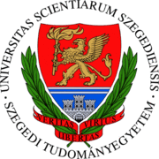
University of Chemical University of Szeged
Technology and Metallurgy

Wroclaw University of Middlesex University
Environmental and Higher Education
Life Sciences Corporation

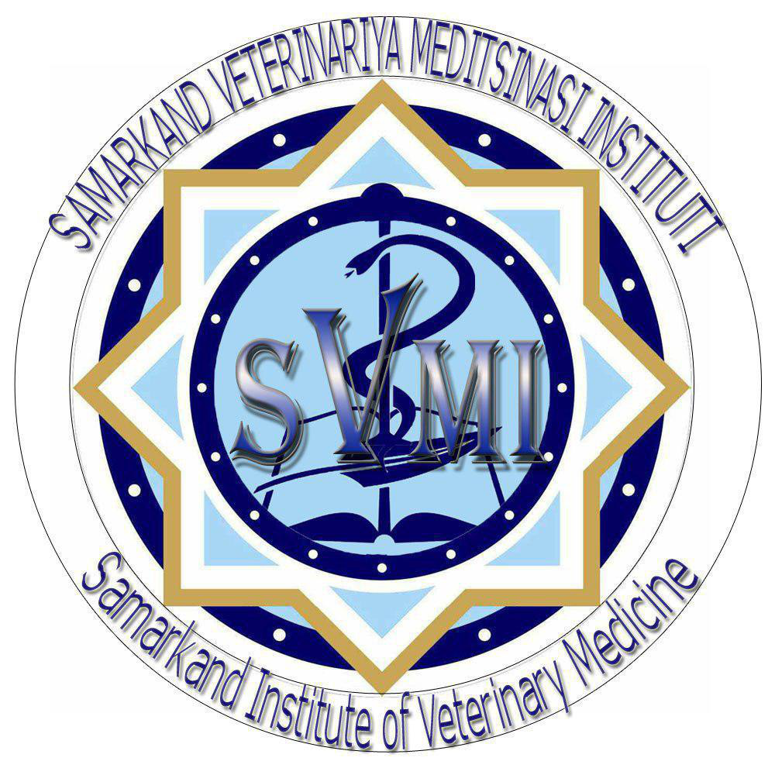
Samarkand Institute of Andijan branch Tahkent state Veterinary Medicine Agrarian university

Ministry of Higher and Termiz state university secondary specialized
Education of the Republic
of Uzbekistan

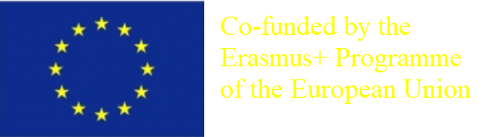

  - 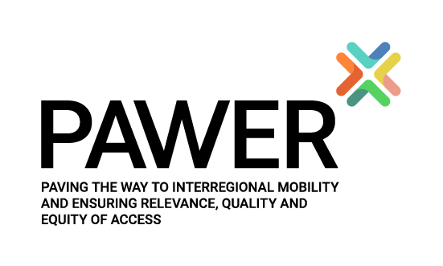

  - 574099-EPP-1-2016-1-IT-EPPKA2-CBHE-SP
  - PAWER: Paving the way to interregional mobility and ensuring relevance, quality and equity of access

  - PAWER: Mintaqalararo mobillikka o'tishni yo'lga qo'yish va imkoniyatlarning ahamiyatliligi, sifat va tengligini ta'minlash

  - PAWER: Прокладывание пути к межрегиональной мобильности и обеспечения актуальности, качества и равенства доступа

  - www.pawer.uniwaq.it
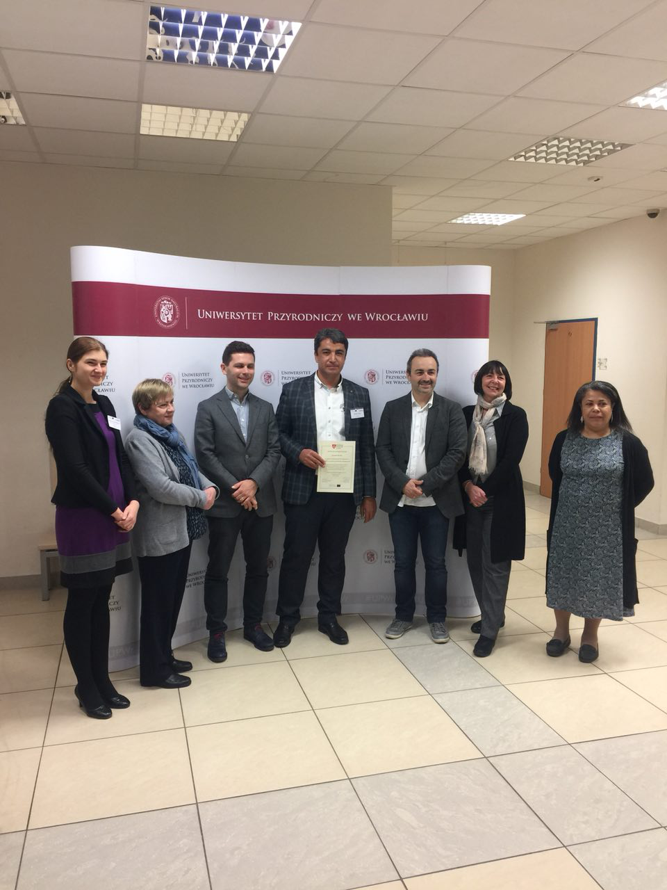  574099-EPP-1-2016-1-IT-EPPKA2-CBHE-SP  PAWER: Mintaqalararo mobillikka o'tishni yo'lga qo'yish va imkoniyatlarning ahamiyatliligi, sifat va tengligini ta'minlash  Loyiha muddati: 15/10/2016 - 14/10/2019  Hamkorlar:  L'Aquila universiteti (IT); Angliya: Middleseks universiteti Oliy ta'lim korporatsiyasi  Vengriya: Szeged universiteti  Bolgariya: Kimyoviy texnologiya va metallurgiya universiteti  Polsha: Wroclaw ekologiya va hayot fanlari universiteti  Gruziya: Akaki Tsereteli Davlat Universiteti, Ilia Chavchavadze Davlat Universiteti, Shota Rustaveli davlat universiteti, Gruziya Ta'lim va Fan Vazirligi  Qozog'iston: Evroosiyo Innovatsion Universiteti, Qozoq Milliy Agrar Universiteti, Seifullin Qozoq Agrotexnika Universiteti, Shokan Ualikhanov nomidagi Kokshetau Davlat Universiteti, Ta'lim va Fan Vazirligi  Qirg'iziston: Qirg'iz Milliy Agrar Universiteti, Qirg'iz Milliy Universiteti, O'sh Davlat Universiteti, Ta'lim va Fan Vazirligi | O'zbekiston:Andijon Qishloq Xxo'jalik Instituti, Samarqand Qishloq Xo'jalik Instituti, Termiz Davlat Uuniversiteti, Oliy va o'rta maxsus ta'lim vazirligi  Loyihaning maqsadi: Loyihaning maqsadi kreditlarni ajratish va baholash tizimini ishonchli sxemasini taqdim etuvchi Evropa Ittifoqi bilan hamkorlikda 4 ta turli mintaqaga tegishli bo'lgan 8 ta mamlakatning 23 ta muassasasida avvalgi Markaziy Osiyo TEMUS dasturi, Kavkaz, Rossiya va Osiyo va shu hududlardagi EMA2 dasturlari va yangi ECTS qo`llanmasi va EGRACONS tajriba loyihalarda ishlab chiqilgan 5 ta ish sohasiga ajratish va kreditlashni muvofiqlashtirishga qaratilgan.  Project title:  574099-EPP-1-2016-1-IT-EPPKA2-CBHE-SP  PAWER: Paving the way to interregional mobility and ensuring relevance, quality and equity of access  Project duration: 15/10/2016 - 14/10/2019  EU partners:  Grantholder: University of L'Aquila (IT)  UK: Middlesex University Higher Education Corporation; HU: University of Szeged  BG: University of Chemical Technology and Metallurgy; PL: Wroclaw University of Environmental and Life Sciences  Beneficiary institutions:  Azerbaijan: Khazar University, Caucasus University, Ministry of Education of the Republic of Azerbaijan  Georgia: Akaki Tsereteli State University, Ilia Chavchavadze State University, Shota Rustaveli State University, Ministry of Education and Science of Georgia  Tajik State University of Commerce, Ministry of Education and Science |  | Kazakhstan: Innovative University of Eurasia, Kazakh National Agrarian University, Seifullin Kazakh Agro Technical University, Shokan Ualikhanov Kokshetau State University, Ministry of Education and Science  Kyrgyzstan: Kyrgyz National Agrarian University, Kyrgyz National University, Osh State University, Ministry of Education and Science  Mongolia: Mongolian University of Science and Technology, National University of Mongolia, The Ministry of Education and Science Russian Federation: Saint - Petersburg State University of Telecommunications, Siberian State University of Telecommunications and Information Sciences, Ministry of Education and Science  Tajikistan: Kulob State University, Khujand State University, Technological University of Tajikistan  Uzbekistan:  Andijan Agricultural Institute, Samarkand Agricultural Institute, Termez State University, Ministry of Higher and Secondary Specialised Education Kazakhstan: Kokshetau State University, International, Information Technology  Objectives: The project proposal intends to harmonise the credit allocation and grading system in 5 study areas jointly developed in previous projects in 23 institutions from 8 countries belonging to 4 different regions, besides EU, providing a reliable scheme for credit and grades transfer, and is based  on previous experiences of the partnership in TEMPUS Programme in CA, Caucasus, Russia and Asia and EMA2 projects in the same regions, and on the new ECTS Guide and pilot project EGRACONS  - www.pawer.uniwaq.it  - www.pawer.uniwaq.it
Mo'g'uliston: Mo'g'ul Fan va Texnologiya Universiteti, Mo'g'uliston Milliy Universiteti, Ta'lim va Fan Vazirligi
Rossiya Federatsiyasi: Sankt-Peterburg Davlat Telekommunikatsiya Universiteti, Sibir Davlat Telekommunikatsiya va Axborot Fanlari Universiteti, Ta'lim va Fan Vazirligi
Tojikiston: Kulob Davlat Universiteti, Xo'jand Davlat Universiteti, Tojikiston Texnologiya Universiteti, Tojikiston Davlat Savdo Universiteti, Ta'lim va Fan Vazirligi
O'zbekiston:Andijon Qishloq xo'jalik Instituti, Samarqand Qishloq Xo'jalik Instituti, Termiz Davlat Uuniversiteti, Oliy va o'rta maxsus ta'lim vazirligi
Loyihaning maqsadi: Loyihaning maqsadi kreditlarni ajratish va baholash tizimini ishonchli sxemasini taqdim etuvchi Evropa Ittifoqi bilan hamkorlikda 4 ta turli mintaqaga tegishli bo'lgan 8 ta mamlakatning 23 ta muassasasida avvalgi Markaziy Osiyo TEMUS dasturi, Kavkaz, Rossiya va Osiyo va shu hududlardagi EMA2 dasturlari va yangi ECTS qo`llanmasi va EGRACONS tajriba loyihalarda ishlab chiqilgan 5 ta ish sohasiga ajratish va kreditlashni muvofiqlashtirishga qaratilgan.

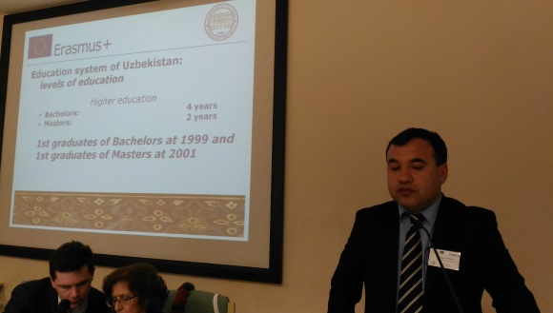
kengaytirishda, maqsadlar va printsiplarni almashishda tadqiqotlar va malakalarning shaffof tan olinishi uchun uchun yanada ko'proq harakatlarni talab etadi.

EHEA doirasida ECTS ni (kreditni yig'ish va uzatish sifatida) yo`lga qo`yish, markazlashgan-o'qituvchi yondashuvidan o`quvchi yondashuviga (SCL) asosli o'zgartirish va o'quv dasturlarini ishlab chiqish va etkazib berishda ta'lim natijalari va yuklamalardan foydalanish, bu hamma uzoq muddatli jarayon va tajribalar natijasida o`quv jarayonining saffofligi va o`qiy olish darajasini oshirdi va mobillikni natijalarining institutdan institutga va davlatdan davlatga tan olinishiga, shuningdek EHEA institutlari o'rtasida qisqa muddatli o'qish davrida muvaffaqiyatli ta'lim olish imkonini yaratdi ("kreditning mobilligi ").
EM dasturlari orqali EHEA va boshqa mintaqalar o'rtasida harakatlarning so'nggi paytlardagi tezlashishi “mobillik” ning yangilangan va global istiqbollari oliy ta`lim muassasalari va tizimlarida hal qilinishi kerak bo`lgan katta qiyinchiliklar borligini ko`rsatdi.

Loyiha natijalari: So'nggi yillarda Yevropa Hamkorlik Dasturlari doirasida EHEA Yevropa Ittifoqi va dunyoning turli mintaqalari o'rtasida oliy ta'lim sohasida siyosiy muloqot uchun yozuvlar nuqtasiga aylandi va bitiruvchilarning ishga joylashishida asosiy rol o'ynadi. Ta'limning o'sib borayotgan global hajmi EHEA va dunyoning boshqa mintaqalari o'rtasida almashinuvni kengaytirishda, maqsadlar va prinsiplarni almashishda tadqiqotlar va malakalarning shaffof tan olinishi uchun uchun yanada ko'proq harakatlarni talab etadi.
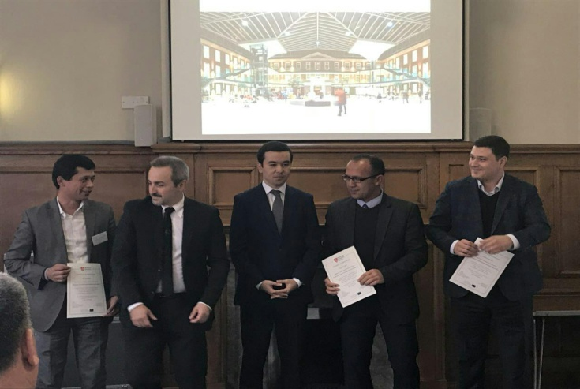
EHEA doirasida ECTS ni (kreditni yig'ish va uzatish sifatida) yo`lga qo`yish, markazlashgan-o'qituvchi yondashuvidan o`quvchi yondashuviga (SCL) asosli o'zgartirish va o'quv dasturlarini ishlab chiqish va yetkazib berishda ta'lim natijalari va yuklamalardan foydalanish, bu hamma uzoq muddatli jarayon va tajribalar natijasida o`quv jarayonining shaffofligi va o`qiy olish darajasini oshirdi va mobillikni natijalarining institutdan institutga va davlatdan davlatga tan olinishiga, shuningdek EHEA institutlari o'rtasida qisqa muddatli o'qish davrida muvaffaqiyatli ta'lim olish imkonini yaratdi.
  - www.pawer.uniwaq.it
574099-EPP-1-2016-1-IT-EPPKA2-CBHE-SP  PAWER: Прокладывание пути к межрегиональной мобильности и обеспечения актуальности, качества и равенства доступа  Срок реализации проекта: 15/10/2016 - 14/10/2019  Партнеры:  Университет L'Aquila (Италия)  Великобритания: Корпорация высшего образования Университета Мидлсекс  Венгрия: Университет Сегеда  Болгария: Университет химической технологии и металлургии  Польша: Варшавский университет окружающей среды и наук о жизни  Узбекистан: Андижанский сельскохозяйственный институт (АндСХИ), Самаркандский сельскохозяйственный институт (СамСХИ), Термезский государственный университет (ТерГУ), Министерство высшего и среднего специального образования (МВССО)  Цели проекта: Проект направлен на гармонизацию процесса определения наполнения кредитов (зачетных единиц) и системы оценки по 5 учебным направлениям, которые были совместно | O'zbekiston:Andijon Qishloq Xxo'jalik Instituti, Samarqand Qishloq Xo'jalik Instituti, Termiz Davlat Uuniversiteti, Oliy va o'rta maxsus ta'lim vazirligi  Loyihaning maqsadi: Loyihaning maqsadi kreditlarni ajratish va baholash tizimini ishonchli sxemasini taqdim etuvchi Evropa Ittifoqi bilan hamkorlikda 4 ta turli mintaqaga tegishli bo'lgan 8 ta mamlakatning 23 ta muassasasida avvalgi Markaziy Osiyo TEMUS dasturi, Kavkaz, Rossiya va Osiyo va shu hududlardagi EMA2 dasturlari va yangi ECTS qo`llanmasi va EGRACONS tajriba loyihalarda ishlab chiqilgan 5 ta ish sohasiga ajratish va kreditlashni muvofiqlashtirishga qaratilgan.  Project title:  574099-EPP-1-2016-1-IT-EPPKA2-CBHE-SP  PAWER: Paving the way to interregional mobility and ensuring relevance, quality and equity of access  Project duration: 15/10/2016 - 14/10/2019  EU partners:  Grantholder: University of L'Aquila (IT)  UK: Middlesex University Higher Education Corporation; HU: University of Szeged  BG: University of Chemical Technology and Metallurgy; PL: Wroclaw University of Environmental and Life Sciences  Beneficiary institutions:  Azerbaijan: Khazar University, Caucasus University, Ministry of Education of the Republic of Azerbaijan  Georgia: Akaki Tsereteli State University, Ilia Chavchavadze State University, Shota Rustaveli State University, Ministry of Education and Science of Georgia  Tajik State University of Commerce, Ministry of Education and Science |  | Kazakhstan: Innovative University of Eurasia, Kazakh National Agrarian University, Seifullin Kazakh Agro Technical University, Shokan Ualikhanov Kokshetau State University, Ministry of Education and Science  Kyrgyzstan: Kyrgyz National Agrarian University, Kyrgyz National University, Osh State University, Ministry of Education and Science  Mongolia: Mongolian University of Science and Technology, National University of Mongolia, The Ministry of Education and Science Russian Federation: Saint - Petersburg State University of Telecommunications, Siberian State University of Telecommunications and Information Sciences, Ministry of Education and Science  Tajikistan: Kulob State University, Khujand State University, Technological University of Tajikistan  Uzbekistan:  Andijan Agricultural Institute, Samarkand Agricultural Institute, Termez State University, Ministry of Higher and Secondary Specialised Education Kazakhstan: Kokshetau State University, International, Information Technology  Objectives: The project proposal intends to harmonise the credit allocation and grading system in 5 study areas jointly developed in previous projects in 23 institutions from 8 countries belonging to 4 different regions, besides EU, providing a reliable scheme for credit and grades transfer, and is based  on previous experiences of the partnership in TEMPUS Programme in CA, Caucasus, Russia and Asia and EMA2 projects in the same regions, and on the new ECTS Guide and pilot project EGRACONS  - www.pawer.uniwaq.it  - www.pawer.uniwaq.it
разработаны в предыдущих проектах с участием 23 вузов из 8 стран, относящихся к 4 разным регионам, помимо ЕС, обеспечивая тем самым надежную схему перевода кредитов и оценивания, и основана на опыте партнерства в рамках программы Темпус в Центральной Азии, Закавказье, России и Азии, проектов Действие-2 ЭМ в тех же регионах, а также новом Руководстве ECTS и пилотном проекте EGRACONS.

Ожидаемые результаты: В рамках Европейского Пространства Высшего Образования (EHEA), внедрение ECTS (как инструмента накопления и перевода зачетных единиц), фундаментальный переход от подхода, ориентированного на преподавателя к студенческо-центрированному подходу (СЦО), использование результатов обучения и нагрузки в разработке образовательных программ и организации обучения по ним – все это в результате длительного процесса и экспериментирования способствовало повышению прозрачности учебного процесса, его «понятности»,

EHEA doirasida ECTS ni (kreditni yig'ish va uzatish sifatida) yo`lga qo`yish, markazlashgan-o'qituvchi yondashuvidan o`quvchi yondashuviga (SCL) asosli o'zgartirish va o'quv dasturlarini ishlab chiqish va etkazib berishda ta'lim natijalari va yuklamalardan foydalanish, bu hamma uzoq muddatli jarayon va tajribalar natijasida o`quv jarayonining saffofligi va o`qiy olish darajasini oshirdi va mobillikni natijalarining institutdan institutga va davlatdan davlatga tan olinishiga, shuningdek EHEA institutlari o'rtasida qisqa muddatli o'qish davrida muvaffaqiyatli ta'lim olish imkonini yaratdi ("kreditning mobilligi ").
EM dasturlari orqali EHEA va boshqa mintaqalar o'rtasida harakatlarning so'nggi paytlardagi tezlashishi “mobillik” ning yangilangan va global istiqbollari oliy ta`lim muassasalari va tizimlarida hal qilinishi kerak bo`lgan katta qiyinchiliklar borligini ko`rsatdi.

облегчило признание результатов мобильности от вуза к вузу, от страны к стране, а также успешной краткосрочной учебной мобильности между вузами EHEA ("кредитная мобильность"). Всплеск мобильности между EHEA и другими регионами мира в рамках программы ЭМ способствовал созданию обновленной и глобальной перспективы “мобильности”, которая показала наличие серьёзных вызовов и проблем, с которыми приходится сталкиваться и которые предстоит решать вузам и системам образования. Студенты, участвующие в проектах ЭМ, испытывают те же проблемы с признанием периода обучения за рубежом – то, с чем европейские студенты сталкивались на начальных этапах мобильности Эразмус.
Все возрастающее глобальное расширение образования, его масштаба требует дальнейших действий по улучшению обмена между EHEA и другими регионами мира, совместному определению целей и принципов, как прозрачность признания обучения и квалификаций
  - www.pawer.uniwaq.it
574099-EPP-1-2016-1-IT-EPPKA2-CBHE-SP  PAWER: Paving the way to interregional mobility and ensuring relevance, quality and equity of access  Project duration: 15/10/2016 - 14/10/2019  Grant-holder: University of L'Aquila (IT)  UK: Middlesex University Higher Education Corporation  HU: University of Szeged  BG: University of Chemical Technology and Metallurgy  PL: Wroclaw University of Environmental and Life Sciences  Beneficiary institutions  Azerbaijan: Khazar University, Caucasus University, Ministry of Education of the Republic of Azerbaijan  Georgia: Akaki Tsereteli State University, Ilia Chavchavadze State University, Shota Rustaveli State University, Ministry of Education and Science of Georgia  Kazakhstan: Innovative University of Eurasia, Kazakh National Agrarian University, Seifullin Kazakh Agro Technical University, Shokan Ualikhanov Kokshetau State University, Ministry of Education and Science  Kyrgyzstan: Kyrgyz National Agrarian University, Kyrgyz National University, | O'zbekiston:Andijon Qishloq Xxo'jalik Instituti, Samarqand Qishloq Xo'jalik Instituti, Termiz Davlat Uuniversiteti, Oliy va o'rta maxsus ta'lim vazirligi  Loyihaning maqsadi: Loyihaning maqsadi kreditlarni ajratish va baholash tizimini ishonchli sxemasini taqdim etuvchi Evropa Ittifoqi bilan hamkorlikda 4 ta turli mintaqaga tegishli bo'lgan 8 ta mamlakatning 23 ta muassasasida avvalgi Markaziy Osiyo TEMUS dasturi, Kavkaz, Rossiya va Osiyo va shu hududlardagi EMA2 dasturlari va yangi ECTS qo`llanmasi va EGRACONS tajriba loyihalarda ishlab chiqilgan 5 ta ish sohasiga ajratish va kreditlashni muvofiqlashtirishga qaratilgan.  Project title:  574099-EPP-1-2016-1-IT-EPPKA2-CBHE-SP  PAWER: Paving the way to interregional mobility and ensuring relevance, quality and equity of access  Project duration: 15/10/2016 - 14/10/2019  EU partners:  Grantholder: University of L'Aquila (IT)  UK: Middlesex University Higher Education Corporation; HU: University of Szeged  BG: University of Chemical Technology and Metallurgy; PL: Wroclaw University of Environmental and Life Sciences  Beneficiary institutions:  Azerbaijan: Khazar University, Caucasus University, Ministry of Education of the Republic of Azerbaijan  Georgia: Akaki Tsereteli State University, Ilia Chavchavadze State University, Shota Rustaveli State University, Ministry of Education and Science of Georgia  Tajik State University of Commerce, Ministry of Education and Science |  | Kazakhstan: Innovative University of Eurasia, Kazakh National Agrarian University, Seifullin Kazakh Agro Technical University, Shokan Ualikhanov Kokshetau State University, Ministry of Education and Science  Kyrgyzstan: Kyrgyz National Agrarian University, Kyrgyz National University, Osh State University, Ministry of Education and Science  Mongolia: Mongolian University of Science and Technology, National University of Mongolia, The Ministry of Education and Science Russian Federation: Saint - Petersburg State University of Telecommunications, Siberian State University of Telecommunications and Information Sciences, Ministry of Education and Science  Tajikistan: Kulob State University, Khujand State University, Technological University of Tajikistan  Uzbekistan:  Andijan Agricultural Institute, Samarkand Agricultural Institute, Termez State University, Ministry of Higher and Secondary Specialised Education Kazakhstan: Kokshetau State University, International, Information Technology  Objectives: The project proposal intends to harmonise the credit allocation and grading system in 5 study areas jointly developed in previous projects in 23 institutions from 8 countries belonging to 4 different regions, besides EU, providing a reliable scheme for credit and grades transfer, and is based  on previous experiences of the partnership in TEMPUS Programme in CA, Caucasus, Russia and Asia and EMA2 projects in the same regions, and on the new ECTS Guide and pilot project EGRACONS  - www.pawer.uniwaq.it  - www.pawer.uniwaq.it
Osh State University, Ministry of Education and Science
Mongolia: Mongolian University of Science and Technology, National University of Mongolia, The Ministry of Education and Science
Russian Federation: Saint - Petersburg State University of Telecommunications, Siberian State University of Telecommunications and Information Sciences, Ministry of Education and Science
Tajikistan: Kulob State University, Khujand State University, Technological University of Tajikistan, Tajik State University of Commerce, Ministry of Education and Science
Uzbekistan: Andijan Agricultural Institute, Samarkand Agricultural Institute, Termez State University, Ministry of Higher and Secondary Specialised Education
Objectives: The project proposal intends to harmonise the credit allocation and grading system in 5 study areas jointly developed in previous projects in 23 institutions from 8 countries belonging to 4 different regions, besides EU, providing a reliable scheme for credit and grades transfer, and is based on previous experiences of the partnership in TEMPUS Programme in CA, Caucasus, Russia and Asia and EMA2 projects in the same regions, and on the new ECTS Guide and pilot project EGRACONS

Expected Outcomes and Outputs In the last years, with the contribution of European Cooperation Programmes, the EHEA became a reference point for policy dialogue between the EU and several regions of the world on higher education and its key role for employability of graduates. The growing global dimension of education needs further actions for the enhancement of exchanges between the EHEA and other parts of the world, sharing goals and principles, as the transparent recognition of studies and qualifications.
Within the EHEA, the implementation of ECTS (as credit accumulation and transfer), the fundamental shift from a teacher-centred to a learner-centred approach (SCL) and the use of learning outcomes and workload in curriculum design and delivery, as result of a long process and experimentation, increased the transparency and readability of the educational process and facilitated the recognition of mobility from institution to institution and from country to country as well as successful learning mobility between institutions of EHEA for short-term study
periods ("credit mobility").

  - www.pawer.uniwaq.it

